Per scientium salutem
Pedagogical Overview
Per scientium salutem

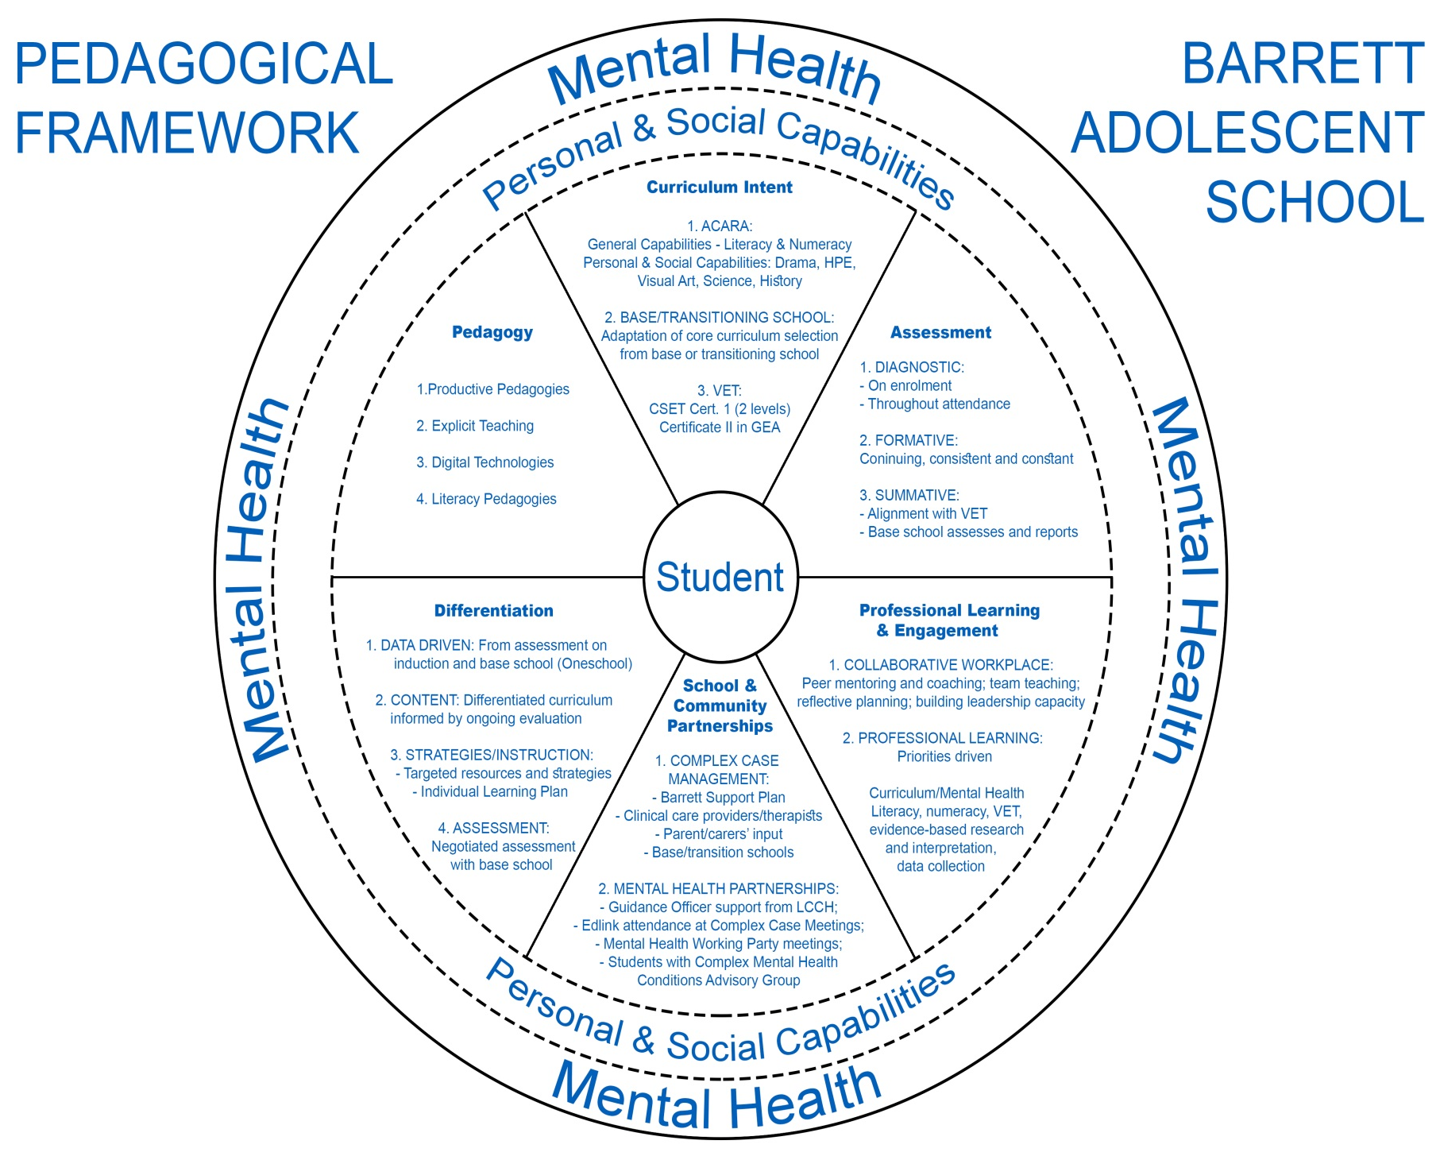

PROFESSIONAL
LEARNING AND
CURRICULUM INTENT ENGAGEMENT /
INSTRUCTIONAL LEADERSHIP

STUDENT

SCHOOL / COMMUNITY
PARTNERSHIPS DIFFERENTIATION

ASSESSMENT (How will students show what they have learned?

